**HVAC Assignment**

**Task Assigned:** To create four or more components of the HVAC template webpage.

**Assigned Date:** 9/05/2024

**Team:**

Karthik Nagaraj Naik – SCRUM master

Narahari Hegde, Pratham Shetty, Srujan – Development Team

Raghu Anand – Product Owner

**Problem Definition:**

Our team was given a template website of a brand named "HVAC" which was a heating, ventilation and air-conditioning equipment provider that also specialized in providing maintenance and repair services of its equipment. Our assigned task from the Product Owner was to create a clone website where our team would have to create at least 4 components of the template website to the best of our abilities.

**Planning:**

Initially our team consisted of 3 members (Karthik Nagaraj Naik, Pratham Shetty and Srujan S), where the SCRUM master (Karthik Nagaraj Naik) along with the dev team had decided that the SCRUM master will create 2 components (navigation bar and services section), Pratham would make the info section and Srujan would make the Footer section. Later however as the students who had gone for interview returned, one of the students, Narahari was interested in joining our team and we assigned him the "Get-a-Quote" and testimonial section.

The git branching strategy used was the Trunk based approach where a Master branch would contain the final code, development branch would contain the code under development and each member of the team had their own respective branches where the members would push their respective code.

**Contributions:**

**Karthik Nagaraj Naik (SCRUM master):**

The SCRUM master was responsible for managing the team and maintaining the version control of the project on git. When it comes to the code, he had implemented the Navigation bar and the Services section of the project as shown below.

1. Navigation bar:

The navigation bar consists of 2 ul tags followed by a div tag that are equally separated. The links react on hover where they turn blue.



Fig. Navigation Bar

1. Services Section:

The services section consists of three card tags where the yellow boxes react on hover and turn into a blue color, additionally, it contains header tags and a button tag.

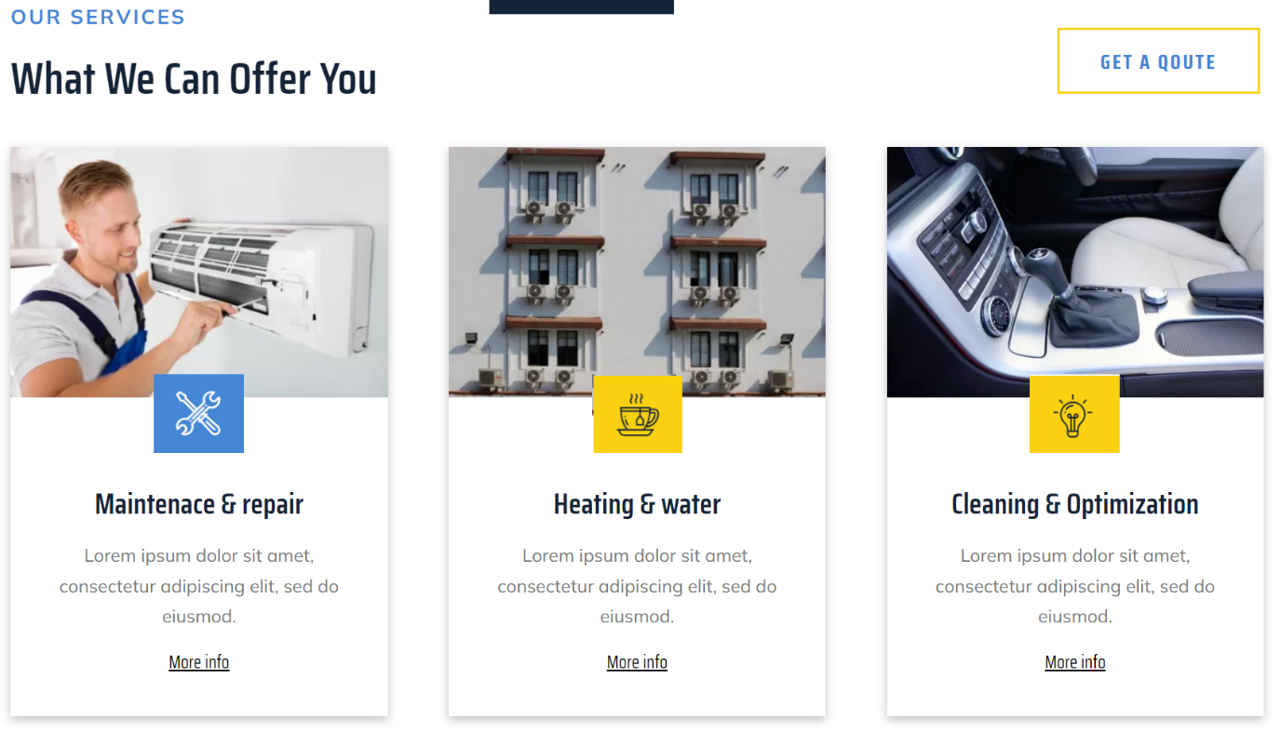

Fig. Services Section

**Srujan S Murthy:** I have contributed to the footer section of the project.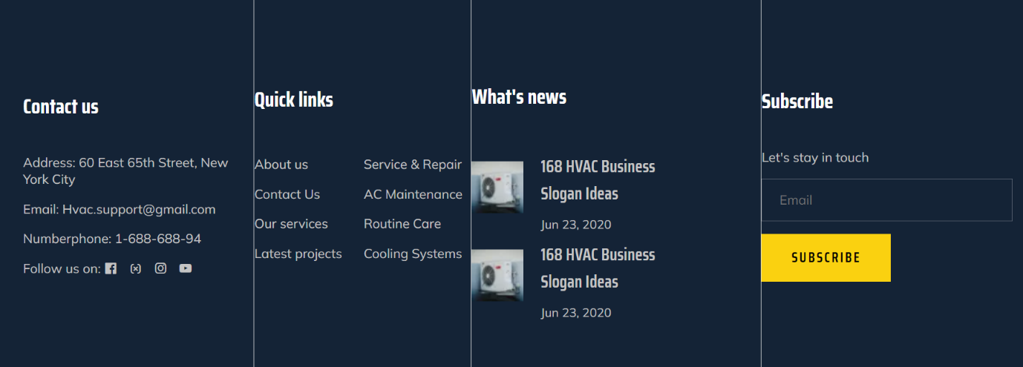

**K P Pratham S Shetty:** Contributed to creation of Company Info and Welcome Section

1. Company Info:

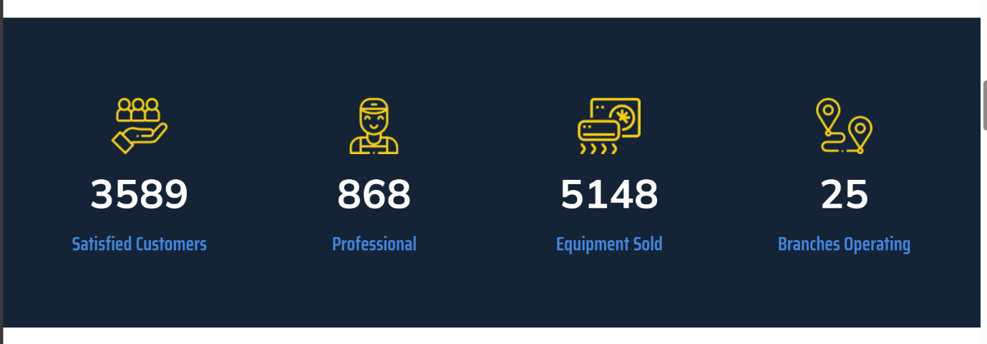Fig. Info Section

* Used visually appealing colors and clear labels to make the data easy to understand.
* High-Quality icons: Included images of satisfied customers, or products/services logos.
* Infographics: Create infographics summarizing key achievements, such as the number of successful projects, happy clients.

1. Welcome Page: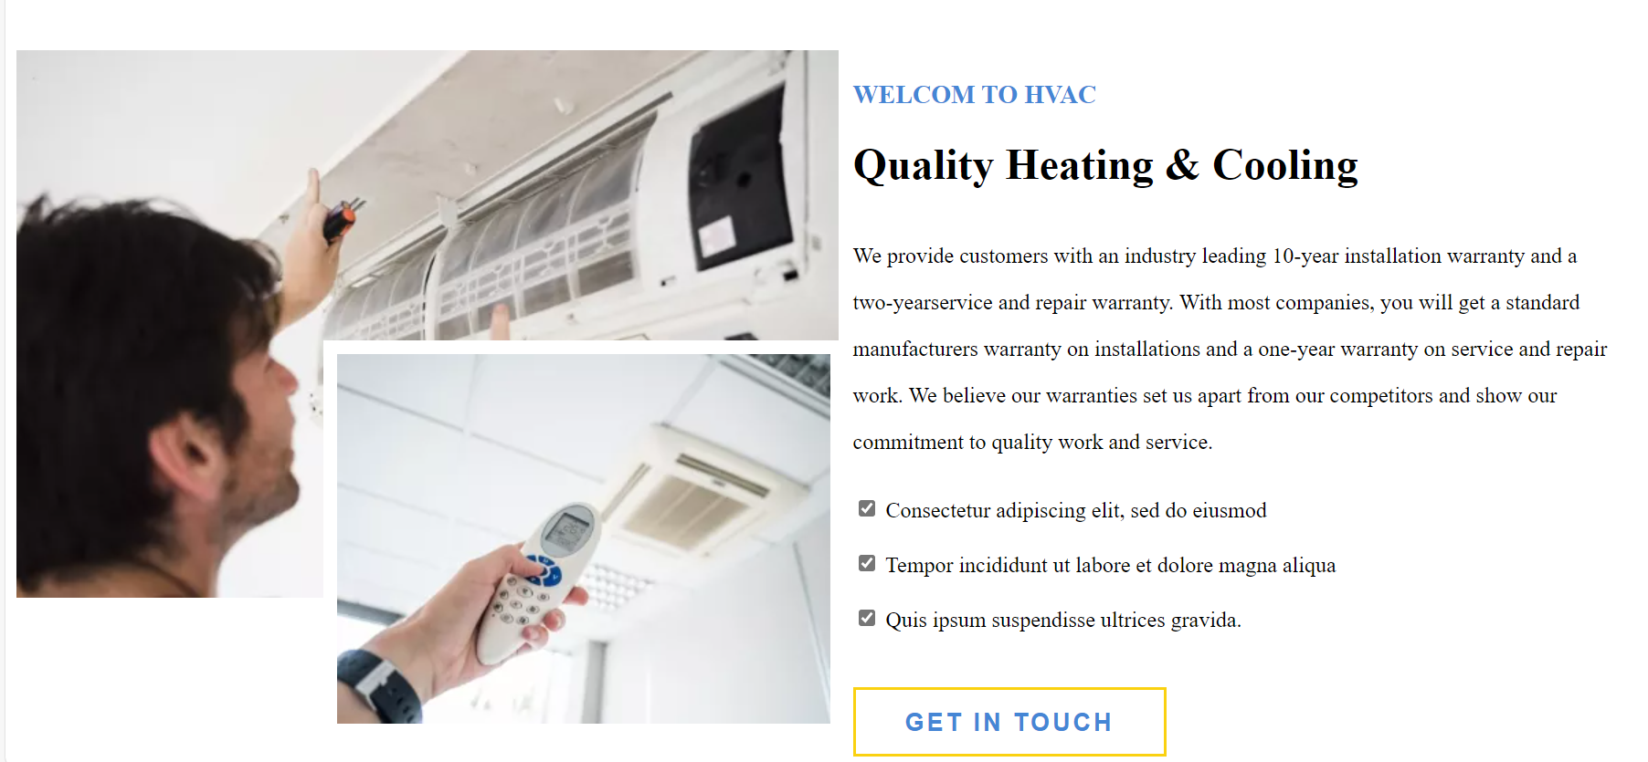

Fig. Welcome Section

* **Clear and Attractive Heading**s: The main title on the page should be clear and concise, introducing visitors to your product or website. Use headings that entice users to explore further.
* **Colorful Design**: Colors draw the eye, so consider using different but matching colors on your welcome page. A visually appealing design can catch visitors’ attention.
* **Informative Images**: Include images that represent your product or company.

***A picture is worth a thousand words, and relevant images can convey the quality of your website or service.***

**Narahari Hegde:** Contributed to Quote Page and Testimonial Section

1. Get Quote Page:
   * This page includes a form where users can input their details.
   * The purpose of this form is to generate a quotation based on the user’s requirement.
   * We designed the form fields (such as name, email, phone number, project details, etc.) and handle the submission process

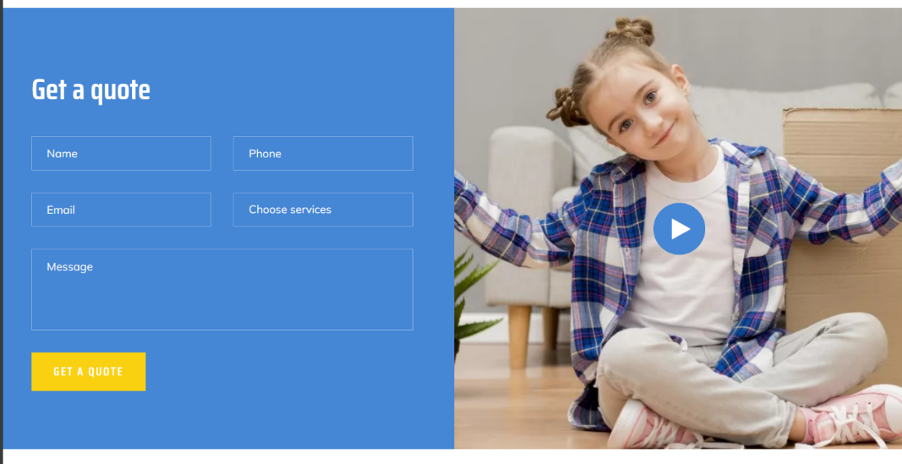

1. Testimonial Section:
   * The testimonial section features three cards containing client testimonials.
   * Each card should display a client’s feedback or positive experience.
   * We enhanced this section by adding client names, photos, and perhaps a brief description of the project they worked on.

